Name:

CODEBOT MISSION 7 LOG - Lesson 3

Pre-Mission Warm-Up
What code must be included before the motors of CodeBot will run?
What code will turn the ‘bot to the left?
Mission 7 Lesson 3 – Hot Pursuit
Mission 7 Introduction
What are the goals of this lesson?
Mission 7 Objective 8
What type of answer is returned by prox.detect()
Given this code, how will you access the value of the left proximity sensor?
Mission 7 Objective 9
Look at each code segment. What is the final value of go_motors after each code is executed?
  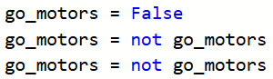 | 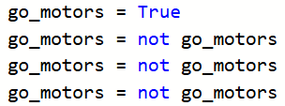
  go_motors = | go_motors =
  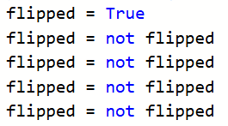 | 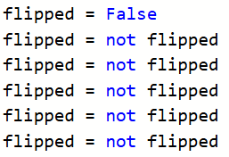
  flipped = | flipped =
Mission 7 Objective 10
After modifying your program to chase an object, try different objects (size, shape, color). Rate how well the ‘bot is able to track (detect) and chase the object, using a scale of 1 (not very well) to 5 (excellent).

Object description, size, color | Observations | Forward speed | Turn speed | Tracking (1-5) | Chasing (1-5)

Mission 7 Objective 11
Give your own example of abstraction.
Post-Mission Reflection
List three new things you learned during this lesson.
Do you think using functions and abstraction improves your code? Why or why not?

